Smart gardening system

Title : Smart gardening system

Submitted By : Battula Surya(190167)

Date : 25-11-2020

Mobile No : 9701731247

(1)

**Table of contents:**

**Introduction-----------------------------------------------------------------------3**

**2.Executive Summary------------------------------------------------------------------- 4**

**3.Business Case Analysis of Project--------------------------------------------------5**

**4.Benchmarking the existing solutions with respect to Project-----------------5**

**5.Project Product specifications-------------------------------------------------------6**

5.**1.1** **Specific Functional Requirements------------------------------------------6**

**5.1.2 Performance Requirements--------------------------------------------------6**

**5.1.3** **Development and Customer Commitment Requirements-------------6**

**5.1.4 Physical Requirements--------------------------------------------------------7**

**5.1.5 Safety Requirements-----------------------------------------------------------7**

**5.1.6 Miscellaneous Product Requirements--------------------------------------7**

**6. Brainstorming & Concept Generation for Project Product--------------------8**

**7. Implementation plan for Project product------------------------------------------9**

**8. Safety--------------------------------------------------------------------------------------10**

**9. Conclusions------------------------------------------------------------------------------10**

**10. References--------------------------------------------------------------------------------11**

**11.Acknowledgements---------------------------------------------------------------------11**

**INTRODUCTION :**

Irrigation is the main problem in agriculture in the countries which are in developing stage.

The main cause is low rainfall due to this more land is not irrigated. Another very important

reason is unplanned usage of water resources by this way more water gets wasted. By the

drip system, water is supplied to the plant zone only thus saving a large amount of water.

Automatic irrigation system can supply water to plants whenever they are in need of water

at regular power supply intervals. Here no need of turning ON/OFF of valves.

By this automatic irrigation system, watering plants at exact time based on soil condition

which will improve crop growth by taking water and minerals from soil when needed. The

aim of the project is to create a sensor network based on low cost soil moisture,

temperature monitoring system which helps to track the moisture of the soil and

temperature in real time and allow water to the plants based on the detecting values and

the type of crop.

The sensors detects the values and provide it to the Arduino microcontroller. It converts

these values into its appropriate form that is executing in it and gives the output in the form

water flow according to the input values. In case, critical situation is detected through these

sensors then a gmail is sent to the owner. A sensor is a device which is used to detect any

changes in the environment and send information to the processor. The sensors in this

project are as follows:

• Soil moisture sensor

• Temperature sensor(DHT-11)

**2.Executive Summary:**

The Smart Garden System is an introductory, easy to build Raspberry Pi based environmental

monitoring and plant watering system using advanced sensors to monitor the soil moisture,

monitor the sunlight, watch the air quality and monitor temperature and humidity. It is

designed to be easily and simply put together and tested with No Soldering Required! The

smart garden monitors the temperature, humidity, and soil moisture of the plant. It has an

automated system that waters the plant when the soil is too dry and sends an email by a two

second delay by the help of SMTP.

This maintains an ideal and consistent soil condition for the plant and makes it convenient for

those who tend to forget to water their plants regularly. Also, the plant can continuously

photosynthesize even when there is no sunlight. We will be using a Raspberry Pi to receive

data from the sensors and control the different actuators. The surrounding temperature, air

humidity and brightness values will be recorded, as well as the soil moisture levels. These

values are analysed by various parameters, which allow users to know the environmental

conditions of the plants when they check on them.

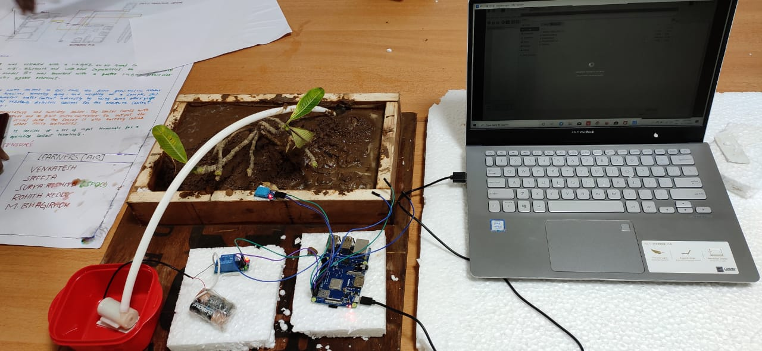

**3.Bussiness case analytic project:-**

our project completely eco friendly it doesnot affect environment. Though this project we can

save both water and electricity.

Estimation of our project:-

|  |  |  |
| --- | --- | --- |
| S.no | Appartus | price |
| 1 | Raspberry pi | 2800 |
| 2 | Soil moisture sensor | 200 |
| 3 | Temperature and humidity sensor | 200 |
| 4 | Relay module | 170 |
| 5 | Submergible motor | 170 |
| 6 | Jumper wires | 175(set) |
| 7 | Dc battery | 90 |

Total investment of our project is 3,805.

If our project is introduced into agriculture most of the percent water and electricity gets

saved, and our project is one-time Investment.If for once our project in planted in any fields

then it requires only electricity to run.it won’t let you to expend so more on it until or unless

any external damage happens to any material used in this project

Based on the sensors our system will works and by using the solar panels we will extract

power from the sun and it gets run.

Without having any idea about the agriculture by using our smart gardening system directly

we can cultivate crops.

**4. Bench marking the existing solutions with respect to Project:**

There are many similar types of projects among those our project is special because when we

removed our soil moisture sensor from soil our motor will turn on it will pump some water to the soil

in between this period our raspberry will send a mail to our phone that your plant is being watered.

SMTP is the special function used in our project which is used to generate a mail to the phone.

Based on the outer temperature in our surroundings also it may release water from the tank.

Based on the crop it takes how much water it wants for cultivating the respected crop.

It releases water not only based on moisture conditions, it will release water based on temperature and humidity conditions also.

**5. Project Product specifications:**

**5.1.1 Specific Functional Requirements:-**

Our main moto of the project is to save electricity and water by using raspberry pi and the respective

sensors.

Here we use to produce 3 different tasks regarding project: -

1) Sending the mail to phone by using SMTP library.

2)Turning off the pump whenever plants gets enough water.

3)Detecting of temperature , humidity and temperature parameters on which watering system of plants

Depends, by using soil moisture and DHT-11 sensors.

**5.1.2 Performance requirements:-**

This project is can work under any conditions since it is being automated because whenever

the plant needs water raspberry receives a message so that by using the submergible motor it

can pump water to the plants.

Based on the crop the amount pumping is depends. When it comes to sugarcane and ground

Nuts it takes more water to produce the crop whereas the rice and wheat it doesnot take that

much water . That plant detection performance is mainly based on code which we enters.

When our project is going there will be no damage to any other things in surroundings.

**5.1.3 Development and Customer Commitment Requirements:-**

Though it is just a project if we implement further means it helps us in many conditions.

Without knowing the proper agriculture, we can cultivate crops . now-a-days days are moving

Water and electricity is going decreased. So that if we implement our project we can save

some amount of water and electricity to be saved.

We can digitalize our project by keeping digitals screens which shows the amount of water

which requires for the crop and to show temperature around us .

**5.1.4 Physical requirements:-**

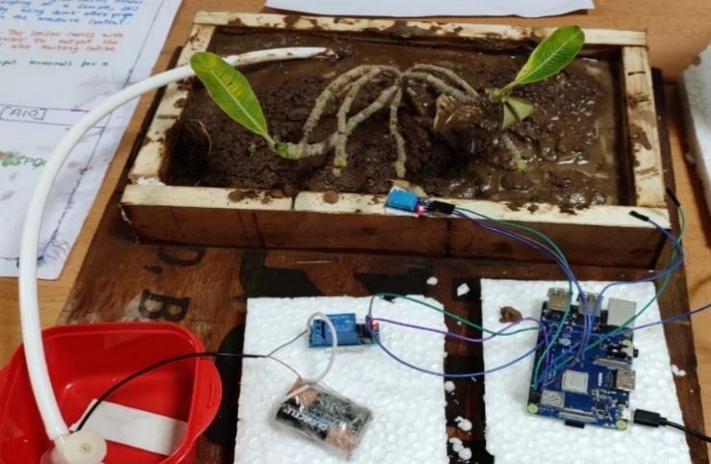

1)The size of project is mainly about the 20cm play wood where all items is to be placed on

it.

2) It weights around 3kg when it is with soil and 0.5kg without the soil.

3)It consumes low cost and less power for the project.

4)It appears in brown color because of play wood it is rectangular in shape.

**5.1.5 Safety measurements :**

Please make ensure that positive and negative terminals of the submergible motor are not

exposed to water directly without having proper insulating substance.

Don’t insert soil moisture sensor forcly into the soil because it may breaks sometime.

**5.1.6** **Miscellaneous Product Requirements:**

To access raspberry pi module 3+ we must have known the basics of python language and how to

connect it to our pc with VNC IP address . For writing code for analyzing of parameters which were

given by sensors to raspberry to find weather plant needs water or not. And we must be aware of the

connections given to sensors.

Python code for our project is is varies to each plant. In the code of soil moisture sensor we can

change threshold moisture percentage for each plant. There are not inbuild functions.

In our project we took papaya plant ,for that it needs nearly 40% of moisture for healthy growth of it.

So in code we kept that 40% as threshold % of moisture so that our soil moisture will detect as wet if

moisture % around the plant is greater than 40% and as dry if it is less than 40%.

**6. Brainstorming & Concept Generation for Project Product:**

**Circuit model of our project**

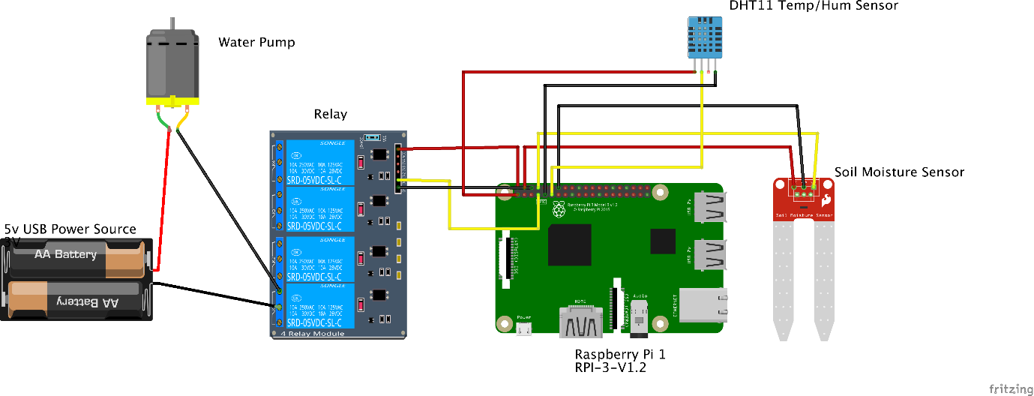

**Practical modal of our project**

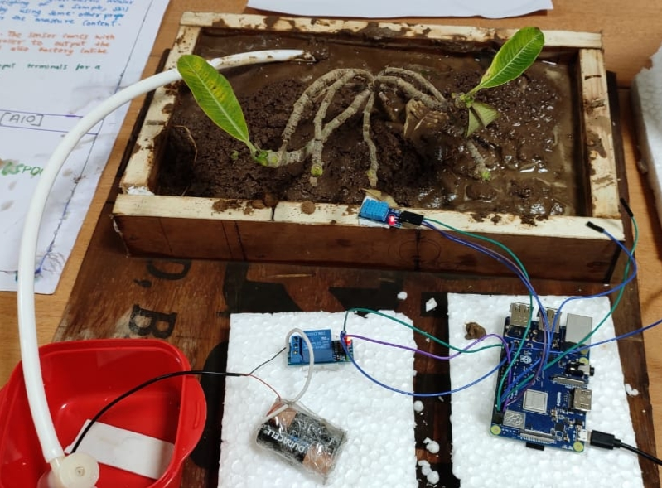

**Hardware preparation for our project**

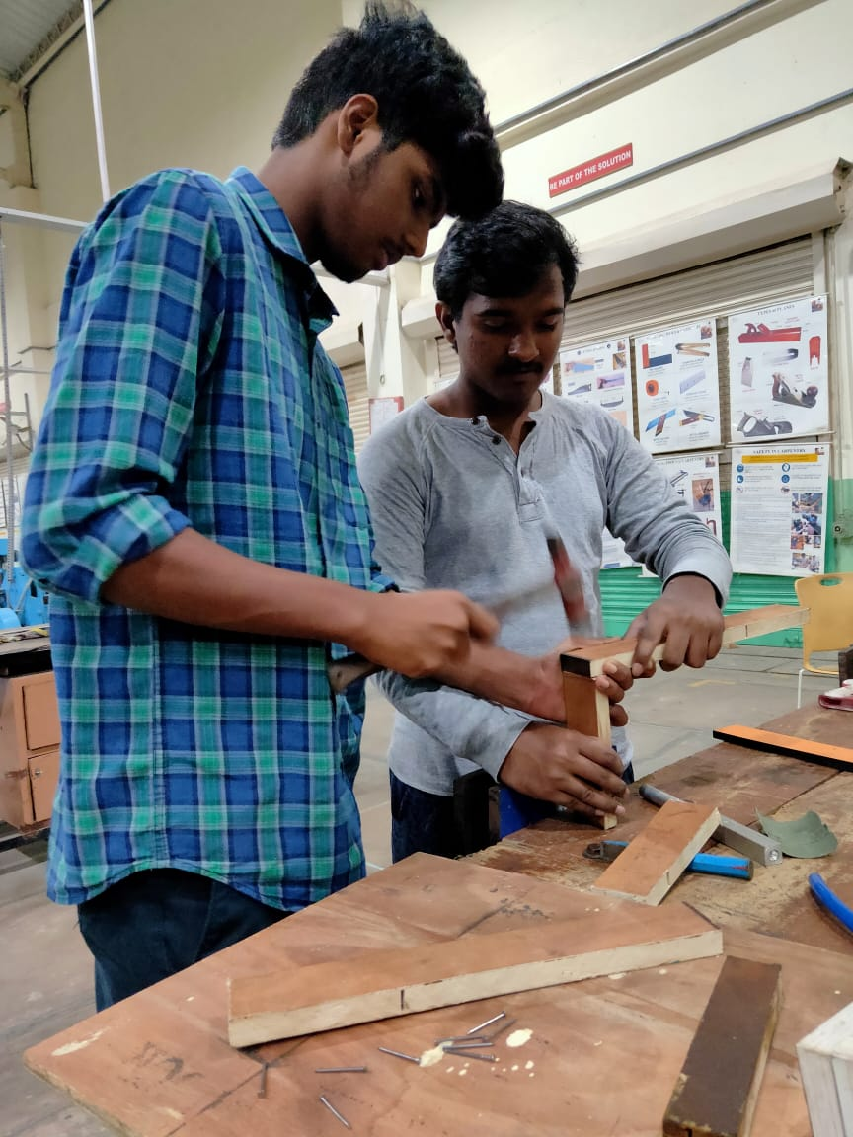

**Methods adapted in our project:**

* We imported sys library, which is an inbuild library for working of raspberry pi.
* We imported **Adafruit_DHT** for proper working of DHT 11 (temperature and

humidity) sensor.

* We imported **RPI .GPIO** for input and output pins of raspberry pi to connect to all

sensors.

* We used led inbuilt function to regulate motor with relay module.

**7.Implementation plan for Project product**

we want to implement this project by implementing following plans

* Introduction solar system to reduce the consumption of electricity.
* Generally, we found that crops are spoiled by so many animals, for resolving that problem we

are going to introduce image processing into this by means of following process

We will keep ultrasonic sensor which detect any object when they are coming near to it. we

commands it to switch on pi camera which captures the object which is coming near to it and

it will start image processing of it. So that it knows weather the coming object is animal or a

human. When it came to know that coming object is animal then it immediately sends mails

to owner and makes some sound, by hearing which animals will go.

* We will introduce PH sensor to this project which will tell the pollution and chemical nature

of surroundings of the plants.

**8. Safety:**

* Here, we are using submersible motor. So please make sure that positive and negative

terminals should be insulated properly. Otherwise they from a closed circuit in water and that

may end up into passing of electricity in water, which leads to electrical shock who are

being in contact with water.

* If load of motor increased, then raspberry pi will burst due to increase of consumption high

power. So please make sure that children are away from the raspberry pi.

* Please make sure that soil moisture sensor is always be in soil, otherwise water will pump

continuously.

**9.Conclusions:**

Now a days in many developed cities, there is scarcity of farmers. So that to get fresh vegetables and

fresh fruits so many software and hardware employees are maintaining their own garden in their

homes itself. In fact, they don’t know the minimum basics of the agriculture and also as they job

holders they are not able spent more time on their gardens. In these types of cases we can use smart

gardening project so that it automatically starts watering to plants when it needs based on the code

which we give , which is based on moisture ,humidity , temperature.

When this project is used in large fields, we can save so much of electricity by decreasing the running

time of motor , decrease the wastage of water and at last it can save the plant by excess of water (if

owner switched on motor but forgets to switch of it).

**10.References:**

The details about hard ware connections of our project are referred from the following website:

<https://www.pubnub.com/blog/smart-automated-iot-plant-irrigation-system-raspberry-pi-pubnub/>

The details about the software part (coding) is referred from the following link:

<https://github.com/Cakhavan/IoT_Plant>

The details about installing of several libraries are :

# <https://www.youtube.com/watch?v=o0sKhTBCl38>(Raspberry Pi Install RPI GPIO)

<https://www.youtube.com/watch?v=JM0p6TCbtGc> (install adafruit_dht11)

<https://www.youtube.com/watch?v=tdges9sFhH4> (installing operating system of raspberry pi)

**11. Acknowledgement:**

We would like to express my special thanks of gratitude to my professor Dr. Rajiv dey who gave me the golden opportunity to do this wonderful project on the topic.

artificial intelligence which also helped me in doing a lot of research and we came to know

about so many things We are really thankful to them and our thanks of gratitude to ativitti

group who helped us a lot to work out in python coding.

Finally ,I would also like to thank my parents and friends who helped me a lot in

finishing this project within limited time .